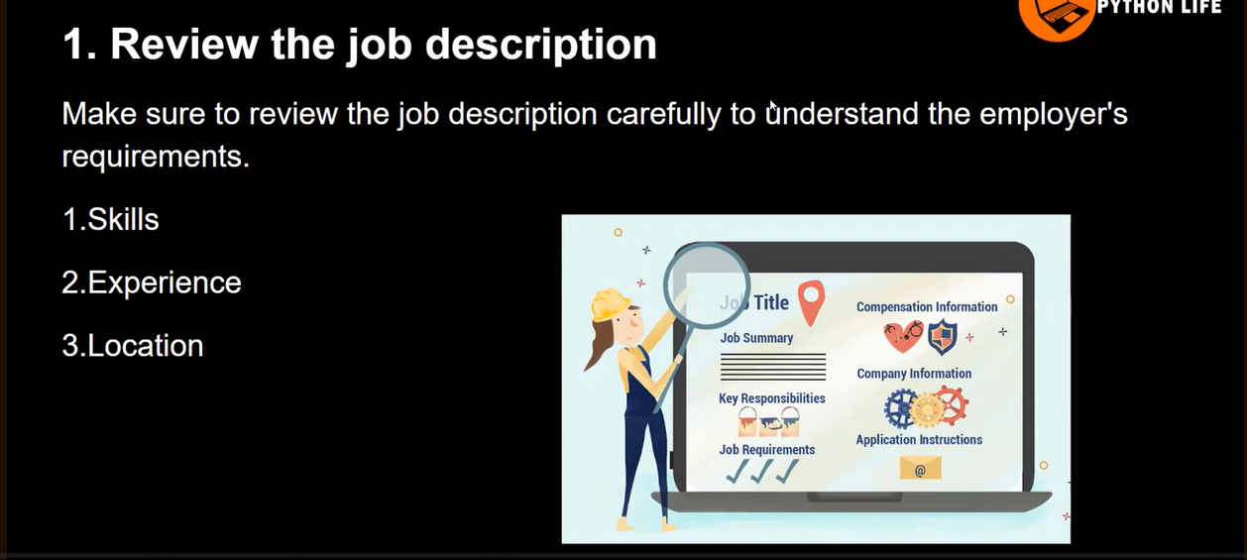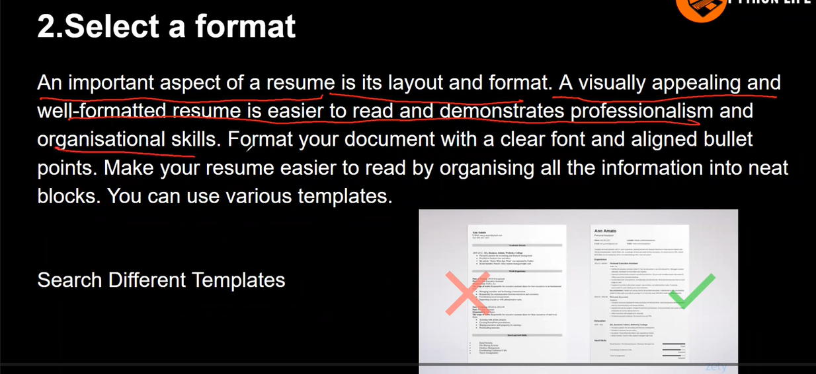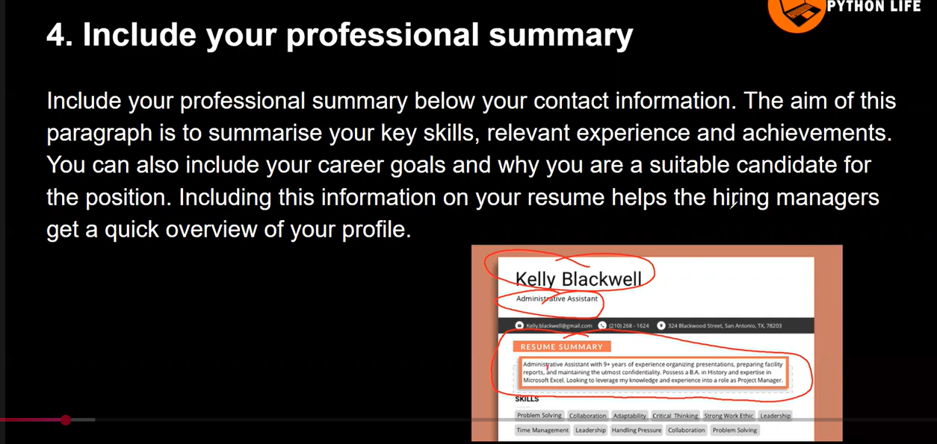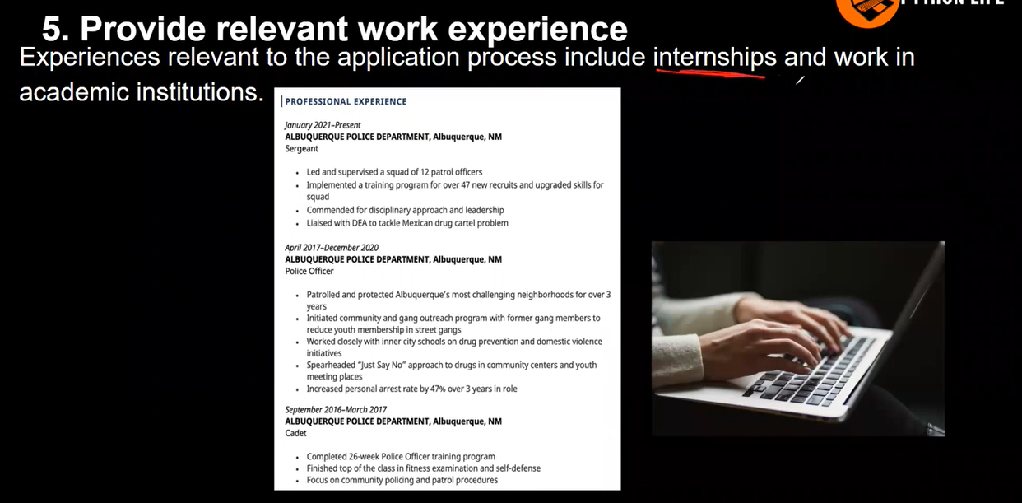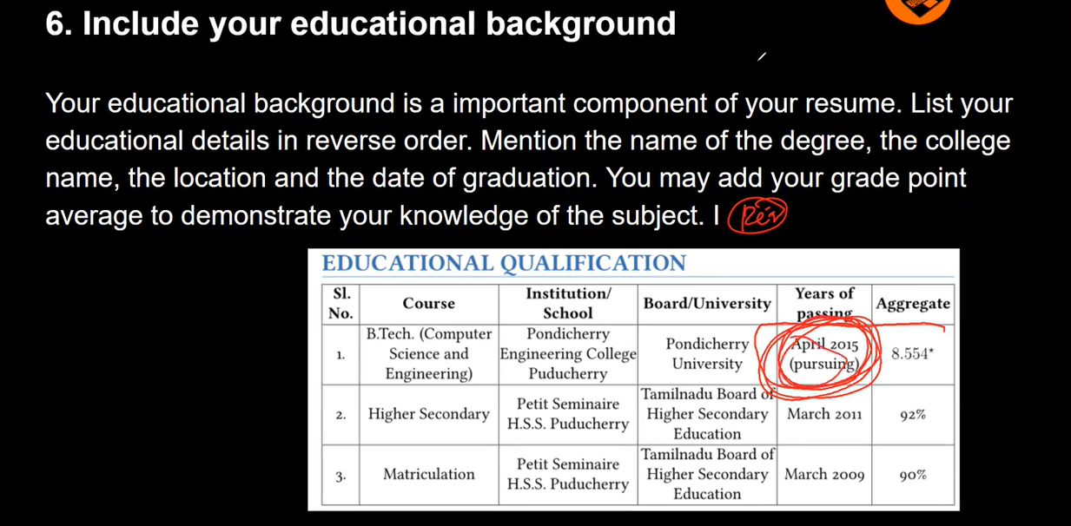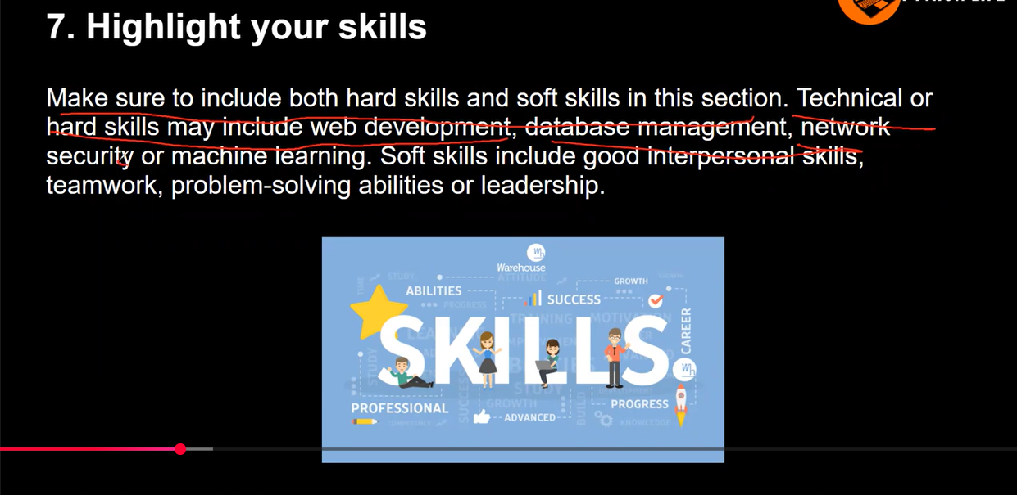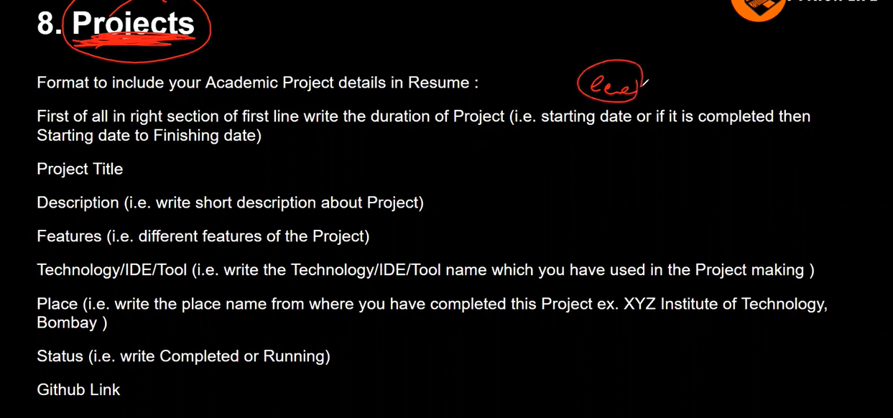

Karthik Nagiri
Bengaluru, India | +91 9121509060|karthik.nagiri@gmail.com | LinkedIn

Analytical and detail-oriented Support Analyst with experience in data retrieval, analysis, and visualization to drive business insights. Skilled in SQL, pandas, Power BI, and finance-related data analytics with a strong foundation in Oracle GL, SQL, and Excel. Proficient in maintaining and optimizing data warehousing systems and ETL pipelines to support large-scale data storage and analytics needs. Working knowledge of AWS cloud-native services, including S3, Athena, Glue, EMR and Airflow, with a focus on integrating data pipelines and enhancing data accessibility.

EXPERIENCE
Data Engineer Support Analyst | Tata Consultancy Services Aug 2022 – Present
• Collaborated and supported data engineers in Designing, maintaining, and optimizing data pipelines using AWS cloud-native services, including S3, Athena, Glue, and Airflow, to improve data accessibility and scalability.
• Maintained ETL processes and data workflows to enhance operational efficiency and support business intelligence initiatives.
• Collaborated with Data analytics team to develop customized reporting solutions aligned with business objectives, leveraging SQL and Power BI. • Ensured data integrity and operations in cloud environments by monitoring and troubleshooting issues in data pipelines.
PROJECTS
• Automated Financial Reporting Pipeline Using SQLite, Pandas, and Airflow: Built an automated ETL pipeline using SQLite for data storage and Pandas for data processing, with Airflow for task scheduling, to streamline financial data reporting. Enabled integration with Power BI Desktop for real-time, daily reports, significantly enhancing reporting
efficiency.

SKILLS
• Oracle SQL | Data Warehousing | JS7 SOS | Pipeline Monitoring | ETL | Incident Management | Data Engineering | OLAP | Python | Apache Airflow | AWS S3 | EMR | AWS Glue | Oracle GL | Power BI | RCA
CERTIFICATIONS
• AWS Certified Cloud Practitioner (Aug 2024 – Present) • Microsoft Certified: Power BI Data Analyst Associate (July 2024 - Present)
EDUCATION
• 2021 Bachelor of Technology in Mechanical Engineering | Chadalawada Ramanamma Engineering college | Tirupathi, India

KARTHIK NAGIRI
📍 Bengaluru, India | 📞 +91 9121509060 | ✉️ karthiknagiri554658@gmail.com | LinkedIn Profile

PROFESSIONAL SUMMARY
Analytical and results-driven Data Engineer & Support Analyst with hands-on experience in data integration, analysis, and visualization. Skilled in Power BI, SQL, Python (Pandas), Excel, and AWS cloud-native services (S3, Glue, Athena, EMR, Airflow). Experienced in ETL development, data warehousing, and business process optimization. Adept at collaborating across teams to deliver reliable data insights, enhance system efficiency, and support enterprise-level data operations.

EXPERIENCE
Data Engineer Support Analyst | Tata Consultancy Services
Jul 2024 – Present | Bengaluru, India
Client: Nest (UK Pensions Project)
- Managed ETL pipelines from BANCS to Oracle, ensuring accurate, timely data loads and financial reporting.
- Built Power BI dashboards and OBIEE reports for business insights.
- Automated AWS data workflows using S3, Glue, Athena, Airflow, and EMR, improving processing efficiency.
- Monitored batch jobs via JS7 and resolved incidents using ServiceNow, maintaining data quality and compliance.
Salesforce & SAP CPQ Developer / Tester | Honeywell
Nov 2022 – Feb 2024 | Line of Business: PAS, LSS, PMC
- Developed and tested Salesforce–SAP CPQ integration for pricing, product, and quote management.
- Configured CPQ rules, validations, and workflows to support Direct and Partner Sales.
- Automated quote validation processes using scripts and workflow logic, improving accuracy.
- Collaborated in UAT and internal testing for seamless deployment.

PROJECTS
Nest UK Pensions Project (Jul 2024 – Present)
Technologies: Power BI, Oracle SQL, AWS S3, Glue, Athena, Airflow, EMR, OBIEE, JS7, ServiceNow
- Managed ETL pipelines and automated workflows, improving data processing efficiency.
- Built interactive dashboards for management insights and financial reporting.
- Monitored batch jobs and resolved incidents, ensuring data quality and compliance.
Honeywell – SAP CPQ Integration with Salesforce (Nov 2022 – Feb 2024)
Technologies: Salesforce Admin, SAP CPQ, Python, Excel, CRM, Product Configuration
- Developed and tested Salesforce–SAP CPQ integration for opportunity, pricing, and quote management.
- Configured CPQ rules and automated validation scripts, improving quote accuracy.
- Supported Direct and Partner Sales workflows and UAT testing.
Automated Financial Reporting Pipeline (SQLite, Pandas, Airflow, Power BI)
- Built ETL pipeline using SQLite and Pandas, orchestrated via Airflow.
- Integrated Power BI dashboards for real-time reporting, improving efficiency by 40%.

SKILLS
Data Analytics & Visualization: Power BI, Excel, Pandas, NumPy
Data Engineering & ETL: Oracle SQL, SQLite, JS7 SOS, Data Warehousing, ETL Design
Cloud & Automation: AWS S3, AWS Glue, Athena, EMR, Apache Airflow
CRM & CPQ Systems: Salesforce, SAP CPQ
Programming: Python, SQL
Other: Oracle GL, OBIEE, RCA, Incident Management, ServiceNow

CERTIFICATIONS
- Microsoft Certified: Power BI Data Analyst Associate — Jul 2024 – Present
- SQL for AI for Techies — Aug 2024
- AWS Certified Cloud Practitioner — Aug 2024 – Present
- Salesforce Administrator Certification — Honeywell Project (2023)
- SAP CPQ Technical Training Certification — Honeywell Project (2023)

EDUCATION
Bachelor of Technology (B.Tech) in Mechanical Engineering
Chadalawada Ramanamma Engineering College, Tirupati, India — 2021
Percentage: 85%

